Design and working model of BTMS

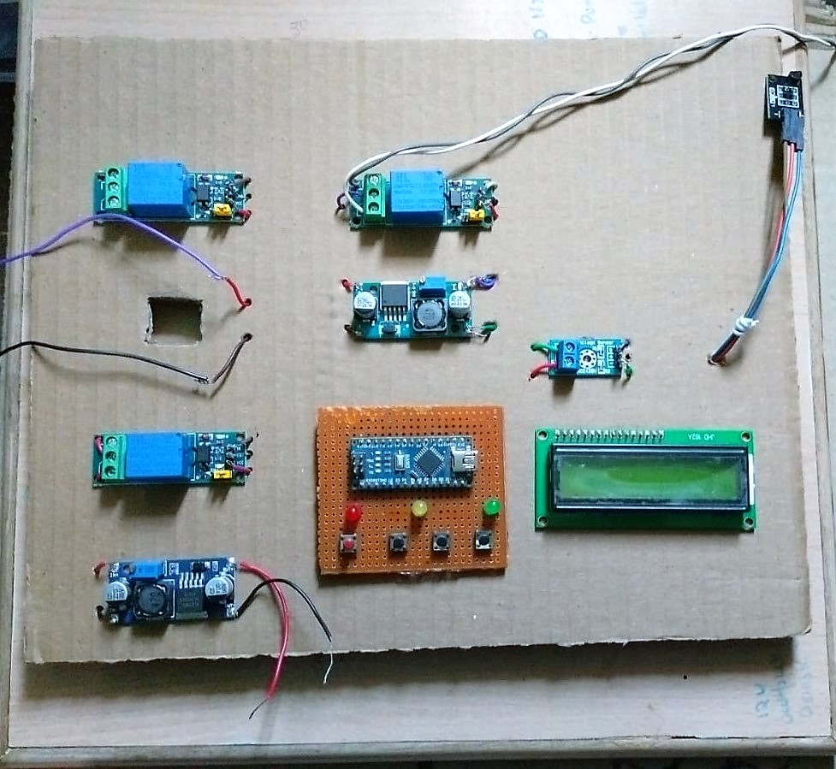

Components used

* 5v relay (3 nos):
* DC-DC Booster 12-25V (1 nos):
* DC-DC Step Down (1 nos)
* Temperature Sensor Module (1 nos)
* Voltage Sensor Module (1 nos)
* Arduino Nano (1 nos)
* LCD Display 16 \* 2 (1 nos):
* 10A Battery Management System:
* 3.7v 2200mAh Cell (9 nos):
* Water Pump (1 nos):
* Leds (3 nos):
* Push Buttons (4 nos):

Function Of Components:

1. 5v Relay:
   * Control Signal: The 5V relay is controlled by a low-voltage signal, typically 5 volts, applied to its coil. When this signal is present, the relay switches its contacts, and when it's absent, the contacts return to their original position.
   * Electrical Isolation: The relay provides electrical isolation between the control circuit and the main circuit. This means that the control circuit, operating at a lower voltage, is separate from the higher voltage or current of the main circuit, ensuring safety and protecting sensitive components.
   * Switching Function: The relay's contacts act as a switch, allowing or interrupting the flow of electricity in the main circuit. When the relay is activated by the control signal, the contacts change position, either closing or opening the circuit, depending on the relay's configuration.

2 DC-DC Booster (12-25V):

* Voltage Boosting: The primary function of a DC-DC booster is to increase the voltage level of a DC power source. In the case of a 12-25V booster, it takes a 12-volt input and boosts it to a higher output voltage, typically up to 25 volts. This increased voltage can be used to power devices or components that require a higher voltage level than what the input source provides.
* Conversion Efficiency: A DC-DC booster typically employs a switching regulator or similar circuitry to efficiently convert the input voltage to the desired output voltage level. These regulators use high-frequency switching techniques to step up the voltage while minimizing power loss and maximizing conversion efficiency.
* Applications: DC-DC boosters have various applications in electronics and electrical systems. They are commonly used in automotive applications to power devices that require higher voltages, such as audio amplifiers or high-intensity lighting systems. They can also be used in renewable energy systems, battery charging, portable electronics, and other scenarios where stepping up the voltage is necessary.

3 DC-DC Step Down (3-24v):

* Voltage Reduction: The primary function of a DC-DC step-down module, also known as a buck converter, is to reduce or "step down" the voltage level of a direct current (DC) power source. It takes a higher input voltage and converts it to a lower output voltage, typically with high efficiency. For example, it can convert a 12-volt input to a 5-volt output.
* Power Regulation: In addition to voltage reduction, DC-DC step-down modules often provide power regulation. They regulate the output voltage to ensure it remains stable and within a specified range, even when the input voltage or load conditions vary. This ensures a consistent and reliable power supply for connected devices or components.

4 Temperature Sensor Module:

* Temperature Sensing: The LM35 is a precision temperature sensor that converts the ambient temperature into an analog voltage signal. It is designed to provide a linear output voltage that is directly proportional to the temperature in Celsius. For example, the LM35 may output 10mV per degree Celsius, so a reading of 300mV corresponds to a temperature of 30 degrees Celsius.
* Temperature Monitoring and Control: The LM35 temperature sensor module is commonly used for temperature monitoring and control applications. The module typically includes additional circuitry such as amplification, voltage regulation, and interface components to provide a convenient and reliable means of interfacing with microcontrollers, data loggers, or other electronic systems. It allows the measured temperature to be processed, displayed, or used for controlling other devices based on specific temperature thresholds.

5 Voltage Sensor Module

* Voltage Measurement: The primary function of a Voltage Sensor Module is to measure the voltage level of an electrical circuit. It typically has input terminals where the circuit's voltage can be connected. The module then processes the voltage signal and provides an output, which can be in the form of an analog voltage or a digital signal, representing the measured voltage level.
* Voltage Monitoring and Protection: Voltage Sensor Modules are commonly used for voltage monitoring and protection purposes. They can be used to monitor the voltage level of a power supply, battery, or any other electrical system. The module can compare the measured voltage against pre-set thresholds or limits and generate alarms or trigger actions when the voltage exceeds or falls below the desired range. This helps in detecting faults, preventing damage to devices, and ensuring the proper functioning of electrical systems.

6) Arduino Nano:

* Arduino Nano is a versatile and compact microcontroller board that provides a wide range of possibilities for creating electronic projects and prototypes. Its small size, ease of use, and extensive community support make it a popular choice among makers, students, and professionals.
* Controls all the components of the Project through code.

7) LCD Display 16 \* 2

* LCD Display 16x2 is an alphanumeric display that can show 16 characters per line with two lines. It is commonly used with micro-controllers and provides a visual output for displaying text, numbers, and symbols. Its parallel interface allows for control and customization of the displayed content, making it useful for a wide range of applications, including information display and user interaction in electronic projects.

8) 10A Battery Management System

* 10A Battery Management System (BMS) is designed to monitor, protect, and control a battery pack with a maximum continuous discharge current of 10A. It ensures safe and efficient battery operation by monitoring key parameters, implementing safety measures, and managing charging and discharging processes.
* BMSs are commonly used in applications such as electric vehicles, renewable energy systems, portable electronics, and other scenarios where battery performance and safety are critical.

9) 3.7v 2200mAh Cell

* Voltage: The 3.7V rating indicates the nominal voltage of the cell. It is a common voltage for lithium-ion batteries, which are widely used in various electronic devices and applications. It's important to note that the actual voltage of a lithium-ion cell can vary depending on the state of charge and load conditions.
* Capacity: The capacity of the cell is measured in milliampere-hours (mAh). In this case, the cell has a capacity of 2200mAh, which represents the amount of charge it can store. A higher capacity means the battery can provide power for a longer duration before needing to be recharged. The actual runtime of a device powered by this cell will depend on the power requirements of the device and the efficiency of the power conversion.

10) 3-5V DC Water Pump

* 3V DC water pump operates on a 3-volt power supply and is used for pumping or circulating water or other liquids. It is commonly used in small-scale applications such as DIY projects, aquariums, fountains, and irrigation systems where low voltage and compact size are required.
* It is important to consider the voltage requirement and specific pumping capabilities of the water pump for selecting an appropriate power supply and ensuring it meets the desired application requirements

11) LED’s

* LEDs are semiconductor devices that emit light when an electric current is applied. They are known for their energy efficiency, versatility in color and size, and durability. LEDs have revolutionized lighting technology and are widely used in applications such as lighting fixtures, automotive lighting, electronic displays, signage, and many more.

12) Push Buttons

* push buttons are mechanical switches that provide momentary electrical connections when pressed. They are commonly used for manual input or control in electronic systems, enabling functions such as power control, triggering actions, and user interface selection. The specific type and configuration of push buttons can vary depending on the desired functionality and application requirements.